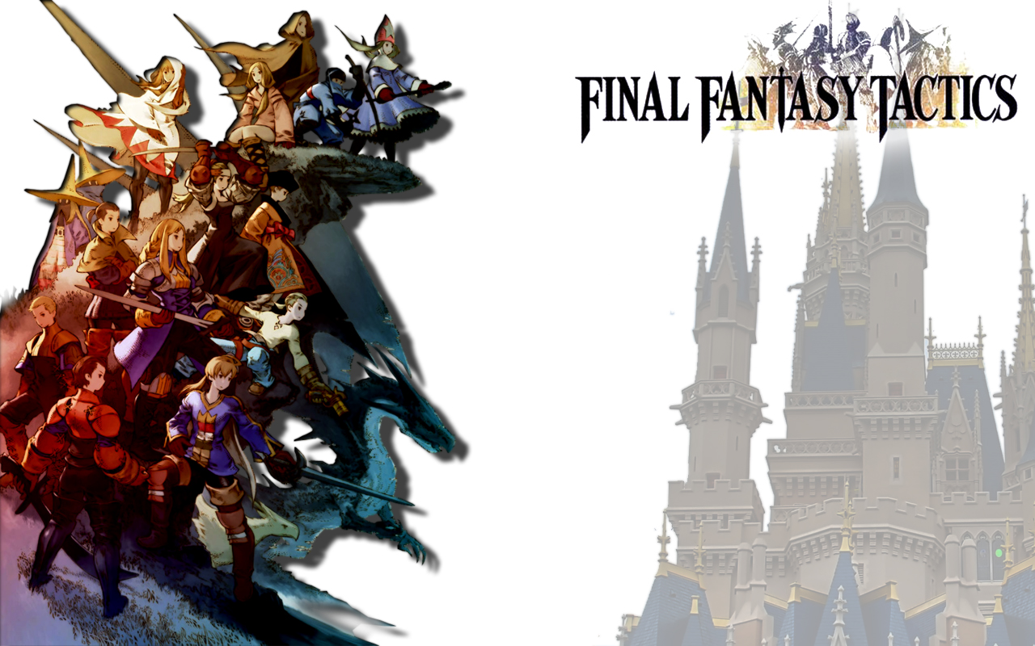Final Fantasy Tactics Worldbook

Summary

Introduction 3

The Game 4

History of Ivalice 5

The Beginning (10000 to 2000 B.C.) 5

The Ronan Empire: The First Empire (2000 to 700 B.C.) 5

The Age of Myth (700 to 50 B.C.) 5

The Life & Death of St. Ajora (50 to 1 B.C.) 6

The Rise of the Glabados Church (25 to 1112 A.C.) 7

The Fifty Years War (1113 to 1163 A.C.) 7

The War of the Lions (1164 to 1166 A.C.) 9

The Glabados Schism (1167 to 1250 A.C.) 10

Timeline 11

Geography of Ivalice 16

FOVOHAM 16

GALLIONNE 17

LIMBERRY 18

ZELTENNIA 19

LIONEL 19

LESALIA 21

Campaign Ideas 23

Game Option: Battle Map 24

The !Move action 24

Zone of Control 24

Weapon Ranges 25

Abilities, Spells and other special ranges 26

Types of Terrain 27

Line of Sight and Line of Effect 27

Giant Characters 28

Job, Actions and Spells in Map Combat 28

New Main Job: Freelancer 35

New Secondary Job: Squire 36

Bestiary 38

## Introduction

Final Fantasy Tactics is a spin-off title in the main Final Fantasy series. Unlike most spin-offs, however, it managed to be a great game on its own, having received universal acclaim upon its release, and critical opinion of the game has improved further over time. It is the first game of the Final Fantasy Tactics series and was released in Japan in June 1997 and in the United States in January 1998. The game combines thematic elements of the Final Fantasy video game series with a game engine and battle system unlike those previously seen in the franchise. In contrast to other 32-bit era Final Fantasy titles, Final Fantasy Tactics uses a 3D, isometric, rotatable playing field, with bitmap sprite characters.

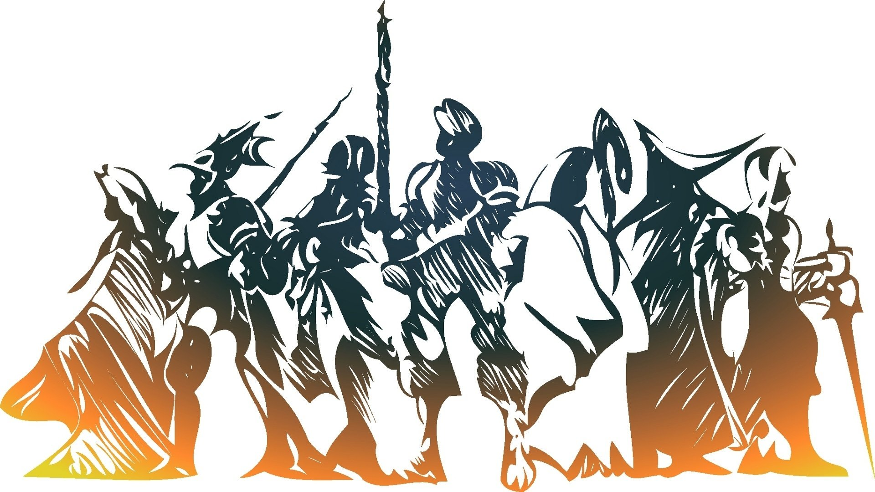For many Final Fantasy players, this represented their first foray into the Strategy RPG genre, with its own quirks and conventions established by several other games that came before, like Shining Force, the Langrisser series or Tactics Ogre. For this reason, and to celebrate the 20th anniversary of the original Japan release of this cult classic, this Worldbook was born. In it, you’ll find the description of the Ivalice setting, detailing its history and geography, campaign hooks, the rules for the FFT-inspired Freelancer Main Job and Squire Secondary Job, and a sample Bestiary from the game. Lastly, should you want to turn your game from traditional JRPG mechanics to a SRPG, you may use the Battle Map rules included.

HUGE THANKS to Paul (Papa Quackers) and Hywel Williams for helping me to write this worldbook.

* **Bruno Carvalho**

## 

## The Game

Final Fantasy Tactics is an RPG that used a three-dimensional isometric battle grid. This difference in functionality led to a game-type that was more akin to chess than the traditional back and forth linear combat of previous Final Fantasy games. Instead of having six characters that were all-essential to the plot, and joined your party over a period, you had a singular main character that would occasionally be joined by story important characters that would depart and rejoin you when the plot demanded they do so. The bulk of your adventuring party was usually made up of interchangeable, nondescript characters whose appearance shifted radically depending on what job class they were.

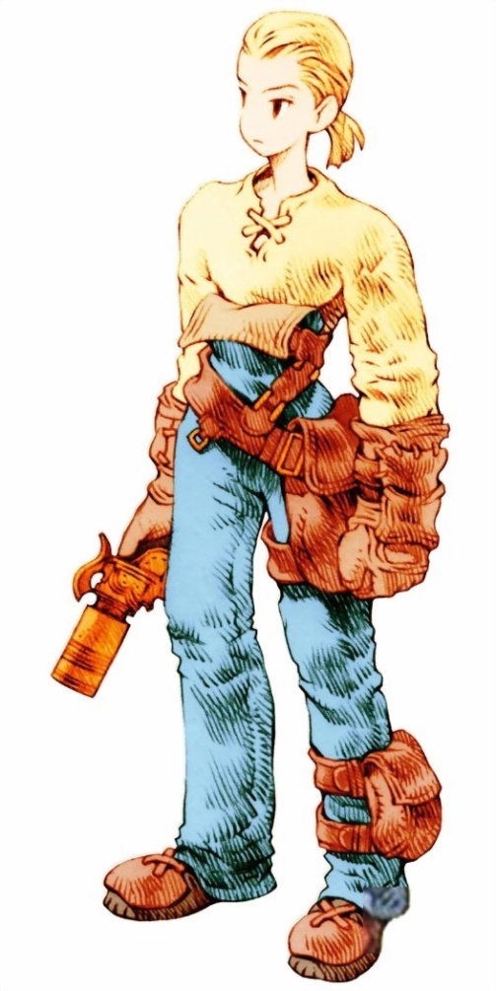The progression of job classes in this system is quite similar to that of the older Final Fantasies, in that there were several different job classes to choose from, but fundamentally different in how certain job classes were unlocked. Instead of obtaining crystals that granted certain job classes automatically, you were given two starting job classes and expanded upon them. Your job progress reveals others, and if you took multiple levels in multiple jobs, your amalgamated experience in those two jobs might reveal another job class that was unique. This system involved a lot of job class switching and of course, a small amount of class mapping to determine which job classes unlocked another.

The story of Final Fantasy tactics revolves around the aftermath of “The 50 Year War”. The kingdom of Ivalice is rife with political and economic discrepancies between the upper and lower class. This problem is compounded by the recent death of the king, whose only heir is an infant, and the need for a regent to rule in that infant’s place. The people are stuck between Prince Goltana, and Prince Large. Known as the Black and White Lion respectively.

This leads into the main plot of the game, known as “The Lion War”, you take on the role of Ramza Beoulve. As the name implies, “The Lion Wars” were the conflicts between the two princes in their attempt to become the ruling regent. Ramza Beoulve is a young noble who takes part in many exploits of the war, discovers hidden corruption and machinations within the most powerful church in the lands, and comes to understand the plight of the common peoples. He was a large factor in the resolution of the war but was actively erased from history.

## 

## History of Ivalice

### The Beginning (10000 to 2000 B.C.)

During this period of time (Estimated from 10000 to 2000 B.C. on the Ajorian Calendar), the majority of humankind lived on the southwestern coast of what years later would become Kaladis. Most of the people of these times were simply tribes of hunter-gatherers. As the age neared its close, however, metallurgy was developed as well as basic magic study. Unfortunately, there are extremely few records during this time partly in thanks to a lack of a written language (which was first developed during the age of the Ronan Empire) although there are some rare ruins left behind that have been found in remote parts of Kaladis.

During this period, the countries that would later become Kaladis and Mizuno were first settled. Ivalice, Romanda, and Ordalia were first settled during the Ronan Empire.

### The Ronan Empire: The First Empire (2000 to 700 B.C.)

History dates that the first true 'civilization' as the Ronan Empire; an empire that grew from a humble farm village near Zeltenia to a huge empire that spanned most of what would become Ivalice as well as parts of Romanda and Ordalia near its end (roughly estimated between 700 and 600 B.C.). Not very much is known about this mysterious empire save that it excelled at the use of magic even compared to the level used by the most powerful of today's magicians. Even more mysterious is what caused its downfall. The Ronan Palace, the center of the empire, was up until its discovery during the Lion Wars a myth in and of itself. Several important ruins came from this era including Matoya's cave, the Tower of Babel, Mirage Tower, and (of course) the Ronan Palace. The Ronan Empire was the first country to develop a written language with Mizuno soon following within its own language known as Nihonjin.

### The Age of Myth (700 to 50 B.C.)

Following the downfall of the Ronan Empire, the territories splintered into four separate countries: Melmond, the Baron Kingdom, the Kushuka Kingdom, and the Palamecian Empire. Like the Ronan Empire, these four nations covered Ivalice and began making inroads into the areas that would become Romanda and Ordalia in later years. This period is largely known as the age of myth due to in part to the amount of fantastic ruins that were left behind as well as the level of technology developed.

Baron Kingdom: a kingdom whose military might rivaled many of the other nations during the age of myth. Baron supported a large number of elite knights as well as a well-known navy of Airships. Baron covered much of what would become Gallione, Fovoham, and western Lesalia.

Kushuka Kingdom: Compared to its neighbors, Kushuka was a center of trade where traders from other countries would come to trade their wares. Unfortunately, for the country itself, its nobility ruled with harsh hand with little concern for their people. After years of abusing the coffers of their nation, the royal family was dethroned by a huge revolution. On a modern map, Kushuka would occupy much of central Lesalia and most of Zeltenia.

Palamecian Empire: Like its neighbors, the Palamecian Empire had a specialty, namely technology. It was the first to develop airships and maintained a fleet that was a fair equivalent of Baron's navy. In addition to its airships, Palamecia also first developed guns that used magical ammunition as well as its "war golems": powerful robots that were used as first line soldiers and guards. The empire covered what would become Lionel. Many historians believe that its capital is deep below Goug Machine City. Palamecia was also the first to develop steam-powered devices and were the first to develop the science of magitek (the fusing of magic and machine).

Melmond: A secluded nation far to the east in what would later become southern Ordalia. More than other countries, Melmond embraced the study of magic in full and supported many academies dedicated to teaching the arcane arts to interested students. Other studies such as history, philosophy, and literature were also popular among Melmond people. Unfortunately, Melmond was considered by many of its neighboring countries to be working with the forces of Lucavi because of their magical might.

Like the Ronan Empire before them, all four kingdoms of the age of myth were destroyed by unknown circumstances. The Zodiac Brave Story first emerged during this era. For those that don't know it, the Zodiac Brave Story is the tale of an evil king who called on the powers of Lucavi, around the year 500 B.C. Lucavi killed the king and caused great havoc throughout the world. In the end, a small group of 12 heroes banded together and used the sacred zodiac stones to become the Zodiac Braves. The Zodiac Braves were able to defeat Lucavi and (supposedly) restored order. Following the defeat of Lucavi, the Holy Ydoran Empire was founded, emerging from the ruins of the old Baron Kingdom. The empire waged several wars, eventually defeating and conquering both Palamecia and Melmond.

### The Life & Death of St. Ajora (50 to 1 B.C.)

The Ajorian Calendar begins its 1st years as the death of St. Ajora and the beginning of the Cataclysm. By the time Ajora Glabados came, three of the four kingdoms of the age of myth had been conquered by the Holy Ydoran Empire, and the Kushuka Kingdom was the only other state to resist the power if its neighbor. The lands that once were Melmond laid abandoned and desolate, as refugees from the Jihads that would follow the rise of the Glabados Church would only resettle them several centuries later.

When Ajora Glabados was young, one day he sprang up, walked to a well, and prophesized that "soon, a calamity will befall this land. I am now sealing this well, and no one can drink from it." Several days later, the "Black Death" plagued Zeltenia. The people who drank from contaminated well water fell ill and died one after another. However, only the families that believed Saint Ajora's words survived and did not fell to disease. Since then, Saint Ajora became worshipped as "The Miracle Child" or "The Son of God".

Soon after these events, word of a new messiah that would lead Ivalice out of the chaos born from years of war. By the time Ajora had reached 18 years old, he had already gained a devoted community of followers. Much like it had years earlier, another ambitious king attempted to summon Lucavi. The emperor had created an army of immense size in the hopes of securing all of Ivalice under the Holy Ydoran Empire’s control. Once again, a new group of Zodiac Braves was created united by St. Ajora to defeat the new Lucavi.

Despite his growing widespread fame, Ajora had made many enemies. The Holy Ydoran Empire feared Saint Ajora's rise to power; they feared his preaching of the coming of God. In those days, there was a much larger church. Clergy of the Pharism faith, the predominant religion, feared Saint Ajora's power. The conclusion is obvious. Saint Ajora was captured with a secret tip from Germonik, Ajora's 13th Apostle. Saint Ajora was executed at the Golgollada execution site. However, Saint Ajora was the "Son of God". God's anger struck at Pheisias, and the Cataclysm began, a series of seismic and volcanic events that shock the world for the next 25 years.

The Cataclysm is often assumed to be the cause behind the loss of Ivalice's most advanced technologies, though the game never outright states this. It also destroyed at least two races, the "winged ones" (possibly the aegyl), the moogles (as told in the Siedge Weald) and the Clockwork City of Goug, and, if the Ivalician myth is true, threatened humanity, leading some to believe it is responsible for the disappearance of the non-human races from Ivalice. The sinking of Mullonde, involving the drowning of an entire state of the Ivalician peninsula, also relate to it. The Cataclysm created the Floating Continent, and destroyed Eureka and of the Fortress of Trials. According to legend, the Hero-King Mesa saved humanity from its effects.

### The Rise of the Glabados Church (25 to 1112 A.C.)

Following the death of Saint Ajora, his remaining apostles established a new church under his name: the Glabados Church, using its namesake's exploits. Soon after its establishment, it was able to cooperate with warring nations that sprung after the cataclysm and subsequent collapse of the Holy Ydoran Empire on a working peace treaty that set up the Atkasha family as the rulers of Ivalice. As part of the peace treaty, Limberry was assimilated into Ivalice. Despite the end of open warfare among the remaining nations, a new cold war developed between the remaining followers of the Fara Clergy and the newly formed Glabados Church.

As Pharism was weakened thanks to the tragedy that led to the destruction of the Ydoran Empire, the Glabados church had no trouble forcing the Phara Clergy and its remaining followers from Ivalice. The remaining Phara followers would, slowly over the next 300 years, help create the nation of Ordalia to the east. The Glabados Church during the first 1000 years of its existence was very powerful, to say the least. Thanks to its iron handed fist, it helped create several different splinter factions of the Glabados religion, including the Argades church, which would later become the official religion of the Romanda Empire.

### The Fifty Years War (1113 to 1163 A.C.)

By 1113, King Denamda II ruled Ivalice, while King Devanne III ruled its neighboring kingdom, Ordalia. Three knightly orders defended Ivalice: the Order of the Northern Sky Knights, led by Ramza's father, Barbaneth Beoulve, the Order of the Southern Sky Knights led by Cidolfus Orlandeau, and the Order of the Eastern Sky, under the leadership of Goffard Gaffgarion. Gustav Margriff and Wiegraf Folles served within the Order of the Northern Sky.

Strife erupted at Zelmonia, a once independent province near to Ivalice's border and now under Ordalian rule. About a century ago, Ordalia invaded and assimilated Zelmonia. Ivalice had secretly provided means to weaken Ordalia; however, the Zelmonian nobles decided to petition for King Denamda's direct intervention. King Devanne III died without naming a successor. His cousin Varoi VI was named as successor, but King Denamda II proclaimed himself as rightful heir, being Devanne's uncle, and declared war against Ordalia.

King Denamda II led the Ivalice army towards the Ordalian capital of Viura. On their way, knights of the three Orders fought valiantly, winning battle after battle. As they were reaching the Ordalian border, King Denamda II fell ill and died soon after, never able to return to his kingdom. The Ivalician army became lost and confused due to their leader's death and Ordalia used that as an opportunity to strengthen its army and defend the borders. The war raged fiercely, reaching a stalemate. A successor to Denamda II, Denamda III, was hastily enthroned to replace his father.

During the stalemate, Romanda's armies crossed the Rhana Strait in an invasion upon Ivalice. Romanda was a military nation ruled by a blood relative of King Varoi VI. King Denamda IV and his Ivalician army held off the invasion through the aid of Fovea’s ruler, Grand Duke Gerrith Barrington, and his assassination squad Khamja.

After three years of fighting Romanda retreated. King Denamda IV was a fearless warrior who personally led his armies in battles against the combined forces of Romanda and Ordalia. The outbreak of Black Death within Romanda also led to their retreat.

With Romanda's retreat, Ivalice continued with the war against Ordalia. Denamda IV died suddenly, believed to be assassinated. He was succeeded by King Ondoria Atkascha III, although the king was a weak-willed man and unfit to rule, and all his decisions being made by Queen Louveria.

Ordalia's ruler Varoi VI also died, and was replaced by Prince Lennard. Due to Ondoria's weakness, Ordallia forced Ivalice to cease fighting.The last battle between Ivalice and Ordallia took place in Zeltennia, and though the Knights of the Orders fought bravely, Ordallia won and occupied the province. Ivalice and Ordallia agreed to a mutual peace treaty, though whispers persist that in reality, Ivalice had surrendered.

After the Fifty Years' War, Ivalice suffered a great loss as the people harbored ill feelings and dissatisfaction to the nobles and the royal family who placed them in the meaningless war. Farmers staged riots and revolted, and many turned banners to join the Corpse Brigade.

Ivalice's economy suffered, as payments could not be made to the knights who had fought in the war due to the spending on weapons and defenses. Many were discharged from the army, and with less food and little money, there was high unemployment and disloyalty to the ruling factions grew.

King Ondoria's two sons died, and the king adopted his younger sister, Princess Ovelia, as his daughter. Soon after, Queen Louveria gave birth to Prince Orinus, causing a conflict over who to become King Ondoria's successor, setting the stage for the War of the Lions.

Rumors spread of King Ondoria's failing health. Since his collapse during Prince Orinus' birthday celebration, it was obvious he was on the brink of death. His advisers, the Board of Chamberlains, delivered news the king was getting better, but the people knew the truth. Soon rumors surfaced that Queen Louveria and other nobles had argued over his successor.

Goffard Gaffgarion was dismissed from the Eastern Sky, and Gustav from the Northern Sky, both on charges of misconduct during the war. Gaffgarion turned to the life of a mercenary, claiming allegiance to the highest bidder.

### The War of the Lions (1164 to 1166 A.C.)

The War of the Lions was fought between the Order of the Northern Sky Knights of Duke Larg under the banner of the White Lion, and the Order of the Southern Sky Knights of Duke Goltanna under the banner of the Black Lion. King Ondoria Atkascha III died due to the Black Death and his heir, Prince Orinus, is only two years old. A regent was sought to rule in the prince's place, and both dukes who were decorated generals in the Fifty Years' War were nominated as regent.

One of the main reasons behind the War is the rift between Queen Louveria and the nobles of Ivalice. Queen Louveria was regarded as a power-mad queen who desires her offspring on the throne so that she may rule the kingdom. The Council of Nobles, out to stop her from asserting influence onto the kingdom, appoints Duke Goltanna as their preferred candidate for the regency.

The first major battle of the War of the Lions, the Battle of Lesalia Plain, was a massive assault of Chocobo Knights from Gallionne on the plains south of the Royal City of Lesalia, where the royal palace is built. The Southern Sky was driven out of the city and forced to their strongholds at Fort Besselat and Limberry Castle. The victory leads to Southern plans mostly revolving around an attack on Lesalia, by sending an army led by Cidolfus Orlandeau to take the city, though it was driven away.

Further Southern attempts to attack Lesalia culminate in the Battle of Groffovia, fought on the plains between Limberry, which was generally pro-Southern, and Lesalia proper. The battle is inconclusive, but within three months casualties reach 40,000, sapping what little public support the war had.

Around this time, Queen Louveria and Chancellor Glevanne were accused of abducting Princess Ovelia to allow for Duke Larg's ascendancy to the throne. In addition, famine overtakes Zeltennia, Limberry, Galionne and Fovoham because of a drought, causing mass starvation amongst civilians.

The losses sustained by the Southern Sky are worsened by the Battle of the Fusse Plains, in which Marquis Elmdore is killed by a stray arrow. He was possessed by the Lucavi Zalera, and fights for the Knights Templar at the Battle of Riovanes Castle.

Despite the death of countless soldiers, the war reaches a stalemate. The Northern Sky plans to make an all-or-nothing attack at Fort Besselat, planning to take it and use it as a base from which they can wage total war against Southern food supply.

The War's decisive battle is the Battle of Fort Besselat, in which Ramza Beoulve intervenes by opening the garrison's sluice, bringing the battle to an indecisive halt. Barich Fendsor, one of the Knights Templar, severely weakening both sides, releases Mossfungus poison into the air. In the confusion, both Dukes are murdered by their respective traitors: Larg by Dycedarg Beoulve and Goltanna by Delita Heiral. As originally planned, the Church offers mediators. Despite the loss of both Order's leaders, their armies are still strong and refuse the idea. This may be because of Ramza's intervention, whereas without it, both sides would have suffered major losses if the sluice were not opened.

Ramza Beoulve travels with his companions to Orbonne Monastery to stop the Knights Templar and the Lucavi's plot for Ultima's resurrection. Killing the Church's forces that dared to stop them, they are teleported to the Airship Graveyard beneath the Necropolis of Mullonde and destroy Ultima, the High Seraph, who wishes to destroy Ivalice. Their own fate after that is a mystery.

With the two sides crippled, the War ends. With the two dukes killed, Queen Louveria imprisoned in Fort Besselat, High Confessor Funebris murdered, Dycedarg slain, and Orlandeau missing and believed dead, Delita Heiral exploits the situation by claiming he rescued Princess Ovelia, marrying her to become King of all Ivalice.

The Church of Glabados engineered the War so that it may take center stage after both sides were weakened to exhaustion. The High Confessor Marcel Funebris, wishing for the Church to gain power over the land, supported both sides secretly and assisted in their plots for the throne. The Church planned to destroy the two Lions from the inside and use the Zodiac Stones to strengthen the Church's military power.

### The Glabados Schism (1167 to 1250 A.C.)

By 1171, the Glabados Church executes Orran Durai as a traitor after writing the Durai Papers. This causes unrest amongst several ordained priests, and one of them, Karling Nox, initiates a movement in Limberry who calls for reformation inside the Church, seeking, in his words, a “return to St. Ajora’s true ways”. This ripples through Ordalia and several of the eastern provinces of Ivalice, and after the Church declares Nox’s status as a heretic, the priest starts to gather a sizable following. Sensing the opportunity to seize lands and riches from the church, several barons and counts declare their conversion to this new interpretation of Ajoran faith, and give shelter to the new converts.

Weakened by the events of the Lion War, Glabados is unable to prevent the rise of the self-proclaimed Ajorans, and this religious divide kept growing for the next 80 years. In contrast, the Heiral dynasty's rule proved to be quite unsuccessful in keeping the power centralized, and had to make several concessions to the nobility to maintain its position as the Ivalice King. These concessions increased the decentralization of the kingdom, empowering the local lords.

By 1240, the religious tensions had turned into violence, with hostilities between Glabados and Ajoran followers leading to several small-scale skirmishes, and culminating with the 1243 massacre of Yardrow, where an angry mob killed a congregation of 500 Ajoran faithful during a religious ritual. This sprung several mutual defense treaties between nobles, creating both the Glabados League, led by the Grand Duke Rudolph Barrington of Fovoham, and the Ajoran League, led by Marquis Henry Elmdore of Limberry. The creation of the two leagues only further increased the tension, but, for the next seven years, peace reigned inside Ivalice.

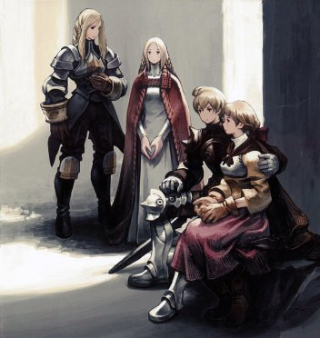In 1250, following a severe disease, king Luther Heiral went into a comatose state. His nephew, Paul Heiral, who was a fervorous devout of the Glabados faith, was designed as Regent. Fearing to be persecuted by its religious beliefs, the Ajoran League voted for a preemptive war against the Regent, intending to replace him with another noble more sympathetic with the Ajoran faith. In response, the Glabados League rallied their troops and this plunged Ivalice into civil war.

### Timeline - All years are B.C. (Before the Cataclysm) or A.C. (After the Cataclysm)

~700 years B.C.

* The Ronan Empire, who ruled somewhere in the world from their floating Castle of Rona, are wiped out by a mysterious disease.

~500 years B.C.

* Head Priestess Mullenkamp of the Ancient Kiltia religion founds the city of Lea Monde.
* Glabados reigns over the Palamecian Empire, the strongest nation in Ivalice.
* According to legend, the king of Mullonde summons a demon that goes on a rampage.
* A great hero appears leading his twelve companions, each bearing a 'stone' (Auracite), and they become known as the Zodiac Braves.

~200 years B.C.

* Holy Ydoran Empire conquers Mullonde and Lionel.
* Orbonne Monastery is built.

~50 years B.C.

* Saint Ajora is born in Bervenia, and is raised in Milados.

22 B.C.

* Saint Ajora is sent as a spy to the Holy Ydoran Empire and starts preaching about the coming Paradise and gathering Zodiac stones in secret.
* In total, Ajora gains 13 disciples - first of which is Balias, last Germonik who was actually an Ydoran agent.

1 B.C.

* Saint Ajora is hanged at Golgollada Gallows by the Holy Ydoran Empire.
* A disaster sinks parts of Mullonde, forms the Black Coral Sea.
* Germonik Scriptures are written by the disciple Germonik.

The Cataclysm

- Moogles and 'winged people' (possible reference to Aegyl) are wiped out immediately, along with several flourishing civilizations. The Hero-King Mesa Ricksen saves humanity.

25 A.C.

* The remaining disciples of Saint Ajora form the Glabados Church.

150 A.C.

* Kingdom of Valendia is founded by king Nalzarc
* The city of Yardrow is established

610 A.C.

* House Atkascha unifies seven warring kingdoms, establishes the Kingdom of Ivalice

788 A.C.

* Shortly before the first democratic elections in Enavia, its president Edgar Black dissolves the anti-monarchistic Laga faction.
* In the same night, Edgar Black is murdered by a certain Ernesta Bulow (aka Simone, aka Oeilvert)
* As a result, the citizens vote for the royalty to continue

790 A.C.

* The top three figures of the royalist movement in Enavia are assassinated, Laga faction is reformed

988 A.C.

* The mathematics teacher Kayi Montesto writes the afterword for his translation of the Veil of Wiyu text from an ancient language

1014 A.C.

* The kingdom of Ordallia annexes the independent state of Zelmonia

1086 A.C.

* Marcel Funebris is born

1088 A.C.

* Simon Penn-Lachish is born

1108 A.C.

* Druksmald Goltanna, son of the Duke Goltanna and cousin of Ondoria III, is born
* Cidolfus Orlandeau, son of Count Orlandeau, is born

1109 A.C.

* Ludovich Baert, son of Viscount Baert, is born

1111 A.C.

* Zalmour Lucianada is born

1112 A.C.

* Goffard Gaffgarion is born
* Master Darlavon is born
* Alphonse Delacroix is born

1113 A.C.

* King Devanne III of Ordallia dies without naming a successor.
* King Denamda Atkascha II of Ivalice proclaims himself heir of Ordallia and declares war.
* Fifty Years' War starts

Between 1113 A.C. and 1136 A.C.

* Ivalician forces march on Zelmonia and conquer it.
* King Denamda II dies on the march of Ivalician forces towards Viura, the capital of Ordallia.
* Denamda Atkascha III is crowned king of Ivalice
* Battles between Ivalice and Ordallia continue on Ordallian ground for these few decades while King Varoi VI of Ordallia tries to push Ivalician forces away from Zelmonia.

1117 A.C.

* Gerrith Barrington, son of Grand Duke Barrington, is born.

1118 A.C.

* Folmarv Tengille, son of Lord Tengille, is born.

1122 A.C.

* Besrudio Bunansa is born.

1123 A.C.

* Nalman Hosse is born.

1127 A.C.

* Bestrald Larg, son of the Duke Larg and relative of Ondoria Atkascha III, is born.
* Dycedarg Beoulve, first son of Lord Barbaneth Beoulve, is born.

1129 A.C. years before FFT

* Messam Elmdore, son of Marquis Elmdore, is born.
* Gustav Margriff is born.
* Loffrey Wodring is born.
* Ondoria Atkascha III, son of Denamda Atkascha IV, is born.

1133 A.C.

* Bestrald Larg and Dycedarg Beoulve become friends.

1134 A.C.

* Wiegraf Folles is born.
* Beowulf Cadmus is born.

1135 A.C.

* Gragoroth Levigne is born.

1136 A.C.

* Zalbaag Beoulve, second son of Lord Beoulve, is born.

1137 A.C.

* King Varoi VI of Ordallia succeeds in pushing Ivalician forces back to Zelmonia, a decades-long period of Zelmonian battles follows between Ivalice and Ordallia.
* Louveria Larg, daughter of Duke Larg, is born.

1139 A.C.

* Romandan forces invade Ivalice via the Rhana Strait.
* The mage Eldibius joins the fight against Romanda.
* Ziekden Fortress is built.

1140 A.C.

* Cletienne Duroi is born
* Orran Durai is born

1141 A.C.

* Milleuda Folles is born
* Reis Dular is born

1142 A.C.

* Ivalice regains control of Riovanes Castle from the Romandan invaders.
* The mage Eldibius disappears.
* Romandan army withdraws from Ivalice due to ferocity of resistance from King Denamda IV and appearance of Black Death at home.

1144 A.C.

* Count Cidolfus Orlandeau becomes friends with Duke Druksmald Goltanna
* Agrias Oaks is born

1146 A.C.

* Meliadoul Tengille, daughter of Folmarv Tengille, is born

1147 A.C.

* Valmafra Lenande is born
* Mustadio Bunansa, son of Besrudio Bunansa, is born
* Duke Bestrald Larg becomes general of the Order of the Northern Sky

1148 A.C.

* Isilude Tengille, son of Folmarv Tengille, is born
* Marach Galthena is born
* Argath Thadalfus is born
* Delita Heiral is born
* Ramza Beoulve, third child of Barbaneth Beoulve, is born

1149 A.C.

* Ovelia Atkascha, daughter of King Denamda IV, is born
* Alma Beoulve, fourth child of Barbaneth Beoulve, is born
* Tietra Heiral is born

1151 A.C.

* Rapha Galthena is born

1155 A.C.

* Cletienne Duroi graduates from Royal Military Akademy of Gariland with top honors, immediately joins Knights Templar.
* Zalbaag Beoulve succeeds the position of Lord Commander of the Order of the Northern Sky after his father.
* The parents of Delita and Tietra Heiral die to the Black Death. Lord Beoulve takes custody of the two children.
* The parents of Marach and Rapha Galthena are killed. The two wander a while as orphans until Grand Duke Barrington takes them in.

1156 A.C.

* King Denamda Atkascha IV of Ivalice dies of either illness or murder. Ondoria III is crowned 18th king of House Atkascha.
* Prince Lennard of Ordallia advances through Zelmonia and invades Zeltennia, and may have reached as far as Limberry.

1157 A.C.

* King Ondoria III marries Louveria Larg and she becomes the queen

1161 A.C.

* King Ondoria III's second-born son dies shortly after birth

1162 A.C.

* Ovelia Atkascha is adopted by King Ondoria III
* Argath Thadalfus becomes knight apprentice in Marquis Elmdore's household
* Orran Durai's father is killed in Count Orlandeau's service, the count adopts him

1163 A.C.

* Prince Orinus Atkascha, third son of king Ondoria III, is born.
* A new copper vein is discovered in Ducatia Mine.
* Ramza Beoulve enters the Royal Military Akademy at Gariland.
* Lord Barbaneth Beoulve dies of poison.
* Delita Heiral enters the Royal Military Akademy at Gariland.
* Goffard Gaffgarion is expelled from the position of division commander of the Order of the Eastern Sky for brutality.
* Veteran soldiers that fought in the ranks of the Dead Men are dismissed without pay, they protest by forming the Corpse Brigade.

1164-1166 A.C.

* Events of the FFT videogame.

1166 A.C.

* Delita Heiral marries Ovelia Atkascha and is crowned king of Ivalice.

1171 A.C.

* Orran Durai writes the Durai Papers, and is executed as a traitor.

1173 A.C.

* Karling Nox writes his thesis for Church reformation, and is branded as a heretic.
* Several nobles of Ordalia and Eastern Ivalice converts to the new Ajoran faith.

1243 A.C.

* The Ajoran league is founded.
* The Glabados league is founded.

1250 A.C.

* Start of the Schism War.

# 

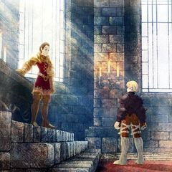

## http://vignette2.wikia.nocookie.net/finalfantasy/images/0/07/Fftwotl_world_map_labelled.jpg/revision/latest?cb=20090803105436Geography of Ivalice

### https://vignette.wikia.nocookie.net/finalfantasy/images/6/60/Crest_of_Fovoham.png/revision/latest?cb=20120928125446FOVOHAM

Fovoham is a territory in the northernmost part of Ivalice. Ruled by Grand Duke Rudolph Barrington, it is separated from the military nation of Romanda by the Rhana Strait. Fovoham played an important role in deterring the Romandan invasion in the Fifty Years' War, thanks to the Grand Duke and his assassin squad Khamja. Nowadays, it is the main force behind the Glabados League, and some even say that the Royal Regent, Paul Heiral, is nothing more than a puppet for the Grand Duke.

**Main Locations**

Riovanes Castle is the home and stronghold of Grand Duk e Barrington. This castle is distinguished by its Romandan-style towers. Its position enables not only a great defensive position but also control of all the trade that flows through northern Ivalice, as Mt. Bervenia serve as natural barrier for the movement of goods and armies.

Walled City of Yardrow, also known as Yardrow Fort City is located east of Riovanes Castle and north of the Royal City of Lesalia. It is a fortress city with some ten centuries of history, protected by thick stone walls built to repel invaders. This walled city has an important past by securing the northern reaches of Fovoham and presenting an important threat to attacks from the Rhana Strait. For centuries, the royal family entrusted this city only to their most loyal vassals, as it is also a prime location for a sneak attack against the capital.

The Yuguewood, also known as Yuguo Woods, is located east of Riovanes Castle. Two-century old yugue trees still grow here, but even this primeval forest was not spared from the ravages of war. Albeit the forest may be a great source of building materials, rumors of ghosts haunting its ancient trees keep anyone except for the most courageous or stupid lumberjacks from using it.

The Fovoham Windflats, also known as Fovoham Plains, is located east of Ziekden Fortress, and is the location of the Windflat Mill, also known as Windmill Hut. These sprawling flatlands are covered by low grasses and battered by fierce winds from the Rhana Straight. They are the main farmland area of the Grand Duchy, and provide food not only for Riovanes Castle, but also to Igros Castle as well.

### GALLIONNE

Gallionne is a duchy in the kingdom of Ivallice. Ruled by Duke Lestrad Larg , it is located in western Ivalice. Its borders are the sea, to the west and south, Fovoham to the northeast and Lesalia to the east. Its seat of power is Eagrose Castle. As such, it was held by the Order of the Northern Sky knights during the War of the Lions. Lestrad is a stalwart ally of the Grand Duke Barrington, and stands for the Glabados League in the upcoming war.

**Main Locations**

Eagrose Castle, also known as Igros Castle, is the high seat of Gallionne and home to Duke Larg, its lord. This city is second in size only to the royal city of Lesalia. During the Lion War, it was the home base of House Beoulve and the Order of the Northern Sky. It is also the site where the Lucavi demon Adrammelech was defeated.

The Magick City of Gariland, also known as Magic City Gariland, is Home to the Royal Akademy for the Magickal arts, famous for producing Elidibus, mage hero of the Fifty Years' War. It is located east of Eagrose Castle and west of the Merchant City of Dorter. During the Lion War, it was controlled by the Order of the Northern Sky and contains the academy where Ramza Beoulve and Delita Heiral trained.

The Merchant City of Dorter, also known as Dorter Trade City, is a city that developed as a hub for overland trade. It is a lively place frequented by all manner of merchants. Located east of the Magick City of Gariland and north of Orbonne Monastery, it is situated a major crossroads in Ivalice. It is also home to the biggest congregation of Ajoran faithful in Gallionne, and a major opponent to Glabados' influence i nside Gallionne.

Ziekden Fortress, also known as Fort Zeakden, is a fortress built during the Fifty Years' War to prevent a Romandan invasion from across the Rhana Strait. It is located east of Eagrose Castle. Nowadays, it is mostly undefended, as there are few hostilities between Romanda and Ivalice, but should it fall to anyone hostile to Gallionne or Fovoham, it may become an important stronghold.

The Brigands' Den, also known as Thieves' Fort, is a small structure built upon a pier, just south of Eagrose Castle. Once a refuge for fishermen, it was, for a time, a home to brigands: the chaos that followed the Fifty Year's War turned it into a notorious hideout for thieves, and the Corpse Brigade used it as its stronghold. After the War of Lions ended, it was again occupied by fishermen and is part of an important route to Mullonde.

Mandalia Plains is a location, famous for its large limestone spires protruding from the ground like the fangs of a great beast. Its white limestone looks like tusks, giving it the name "Beast Plains". It is located southeast of Eagrose Castle and west of the Merchant City of Dorter.

The Siedge Weald, also known as Sweegy Woods, is an ancient forest surrounded on all sides by mountains. It is rumored to have once been inhabited by Moogles. It is located east of the Magick City of Gariland and west of the Merchant City of Dorter.

Lenalian Plateau, also known as Lenalia Plateau, is a barren plateau dotted with jagged boulders, but little flora of which to speak. Located north of the Magick City of Gariland and south of the Fovoham Windflats. As it connects the heart of the Gallionne territory with Fovoham, it is part of the main trade routes that connect Dorter to northern Ivalice.

### File:Crest of Limberry.pngLIMBERRY

Limberry is the easternmost region in Ivalice, ruled by Marquis Henry Elmdore, the young grandson of Messam Elmdore, one of the heroes of the Fifty Years' War who defended the borders of Ivalice from Romandan invaders.

**Main Locations**

Limberry Castle is the stronghold of the Elmdore family, a beautiful white castle rests on the shores of Loch Dolla. Henry Elmdore, who experienced less than twenty winters, rules the land with the passion and the religious fervor only the very young can muster. His father invited Nox himself as his advisor in his court, and was the first ruler to embrace the Ajoran reformation and since his father's conversion, their newfound wealth has helped turn Limberry into an economic powerhouse, and the lands who used to be controlled by the church are more productive than ever.

Dorvauldar Marsh, also known as Dolbodar Swamp, is a rich marshland in western Limberry. The Dorvauldar River carries fertile soil from here to the plains. It is located between Fort Besselat and Limberry Castle. In the last 60 years, there were an intense construction effort, as dams and irrigation channels were built, taming most of the old swamp areas and creating an important farmland area, transforming this into the breadbasket of Limberry.

Lake Poescas was once a large body of water, but now is nothing but a dried lakebed covered in white salt. It is located just east of Limberry Castle, and is haunted by the living dead. Like most of the Zeltennia-Limberry frontier, it is a wasteland devoid of much economic or political importance. Salt is mined from its outskirts, but the fear of the undead prevents this area to become the main producer of this good.

The Beddha Sandwaste, also known as Bed Desert, is a wild desert covering much of western Limberry, located north of the Order of the Southern Sky fortress of Fort Besselat, and the tombs of ancient emperors can be seen buried in the sand. Before the Cataclysm, this used to be an important site of the Holy Empire, but it has gone from lush farmland to sandy desert almost overnight. Caravans travel it frequently, for it is part of an important trade route, connecting northeastern Ivallce and Lionel.

Fort Besselat, also known as Bethla Garrison was the stronghold of the Order of the Southern Sky.It is located between the Dorvaudar Marsh and the Zeirchele Falls. It lies inside the Royal lands of Lesalia, but was taken by a surprise attack by Ajoran forces, and it is under Limberry occupation. The occupation of Bethla marks the start of the Schism War, and its strategic position oversees most, if not all, land-based trade routes that passes to Lionel.

### ZELTENNIA

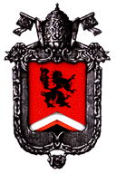Zeltennia is a duchy located in eastern Ivalice, along with the neighboring Limberry. Zeltennia is ruled by the old Jotan Goltanna, youngest son of Druksmald Goltanna, who fought in the Fifty Years' War and is a descendant of late King Denamda II. Straddled at the easternmost border of Ivalice, Zeltennia was known as the fiercest battlefield during the Fifty Years' War. It is prone to invasion by the kingdom of Ordallia, and was almost lost to the Ordallian side, if not for the defenses led by Cidolfus Orlandeau, a knight serving House Goltanna. Nowadays, it sides with Limberry in the Ajoran League.

**Main Locations**

Zeltennia Castle is the stronghold of the Goltanna House. It was heavily reinforced during the Fifty Years' War, and now is a formidable stronghold. Goltanna's conversion to the Ajoran faith was born not of faith, but of convenience, as the Zeltennia ruler saw itself surrounded by Ajoran believers both in the south and in the east, and foresaw the potential gains from joining the league and the war that was looming on the horizon.

Trade City of Sal Ghidos, also known as Zarghidas Trade City, is hub of trade between Zeltennia and Ordallia. Following the events of the Fifty Years' War, it went into decadence, as the sour relations between Ivallive and Ordallia blocked most of the trade. However, following the Schism and with the newfound wealth in the Dorvaudar Marsh area, it is experiencing a renaissance, and nowadays it bursts with activity.

The Finnath Creek, also known as Finath River, is located between the Free City of Bervenia and Zeltennia Castle. It is an important defensive feature, blocking the advance of armies that could launch an attack from the Free City of Bervenia. Knowing that, Goltanna has positioned most of his armies in a defensive stand in the riverbanks, unsure if he should trespass the imperial land - a hesitation that has not gone unnoticed by his allies.

Mount Germinas, also known as Germinas Peak is in the far east of Ivalice. It marks the highest point of a mountain range that dot the eastern border of both Zeltennia and Limberry, directing most trade to the nearby Sal Ghidos City. Its frozen peaks are the source of most of the rivers that once filled up Lake Poescas, but now direct their course westward to the Finath River.

### LIONEL

Lionel is one of the seven territories of Ivalice. It was once known as the land of the Holy Ydoran Empire and the center of the ancient teachings known as Pharism. Both crumbled after a catastrophe struck the capital, which occurred soon after the execution of Saint Ajora Glabados, who is the central figure in the Glabados and Ajoran faiths. Before the Lion War, Lionel continued its role as a religious territory, ruled by Cardinal Delacroix, a prominent figure in the Church and one of the heroes of the Fifty Years' War. After the War, with the debacle of the Glabados power, Lionel was reformed into a secular duchy, granted to the Lenande family by the Heiral kings.

**Main Locations**

Lionel Castle is located in Southern Ivalice, and is the stronghold of Leonard Lenande, duke of Lionel. It is also the site of Saint Ajora Glabados's capture and of Ramza Beoulve's battle with Cúchulainn. Lionel is currently neutral in the Schism War, and emissaries from both the Glabados and the Ajoran leagues try their best to persuade the duke to join the fight.

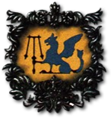The Castled City of Zaland also known as Zaland Fort City, is an elevated city built atop a low mountain, and serves as a gateway to the province of Lionel. It is located in the only land connection between Lionel and mainland Ivalice, and its strategic importance to the whole duchy is paramount.

The Port City of Warjilis, also known as Warjilis Trade City, is located south of Lionel Castle along the coast. As the only merchant city in Lionel, this city developed as a port of transit for trade on the Bugross Sea. Warjjilis is an important harbor not only for Lionel, but also for the entire Ivalice kingdom, and the Lionel fleet stationed there is the undisputed strongest naval fleet in the entire region.

The Clockwork City of Goug, also known as Goug Machine City, is a mining city located in southwestern Lionel. It produces mechanical weapons with generation-old technology. They say the ruins of a lost civilization lie buried beneath the streets of Goug, the Clockwork City. Relics from the age of Saint Ajora, when airships numerous beyond counting filled the skies, and men of iron walked city streets. But the art of crafting such things was lost—if it ever truly existed at all.

The Golgollada Gallows, also known as the Golgorand Execution Site, is the site of Saint Ajora Glabados's execution. It is located south of Lionel Castle and is employed as a public execution ground by the province.

Tchigolith Fenlands, also known as Zigolis Swamp, is located west of Lionel Castle and east of the Clockwork City of Goug. Countless people died here during the Fifty Years' War, changing this once fertile plain into a poisonous fen. Even now, more than a century after that war, the scars will not heal, and rumors that some unholy magic was unleashed there run amongst the common folk.

Balias Tor, also known as Bariaus Hill, is located north of Lionel Castle. It was here that the Holy Ydoran Empire put Balias, the first of Saint Ajora’s disciples, to death. It is a holy place for both the Glabados and the Ajoran faithful.

Balias Swale, also known as Bariaus Valley, is located between Lionel Castle and the Port City of Warjilis, and is the barren valley where Balias, the first of Saint Ajora's disciples, hid from pursuers from the Holy Ydoran Empire.

Mullonde Cathedral, also known as St. Murond Temple, is the main center of Glabados Church, and sits on an island to the west of the Lionel mainland. Once an independent archbishopric, Mullonde was incorporated into the Lionel Duchy after the Lion War, but remains under the Church control.

### LESALIA

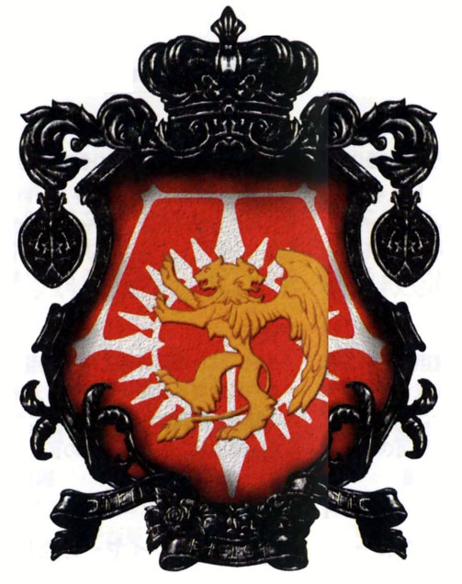Lesalia is the center of the kingdom of Ivalice in Final Fantasy Tactics. It was the seat of the Atkascha royal family, who have ruled from this region even during the Fifty Years' War and the War of the Lions, but now houses the Heiral royal family. The signs of wealth and luxury persisted even as Ivalice faced war after war.

**Main Locations**

The Royal City of Lesalia, also known as Lesalia Imperial Capital is the capital of the kingdom Ivalice. It is the high seat of the Crown, and in it towers the luxurious keep that houses the Ivalice's royal family. As the king is comatose and Paul Heiral, the regent, dances by the music played by the Fovoham Grand Duke, the royal lands are aligned with the Glabados league, but the Regent's inability to coordinate his armies has led to many early Ajoran victories. Once he can join forces with the main Glabados armies, the tides of this war may turn.

The Mining Town of Gollund, also known as Goland Coal City, is located south of the Royal City of Lesalia and contains a large coalmine. Rich in mineral resources, these Highlands where the town lies are also battered by year-round snowstorms.

The Bervenia Free City, famous for being Saint Ajora Glabados's birthplace, is under the direct control of the Church of Glabados. It is located on the road between the Royal City of Lesalia and Zeltennia Castle. It is the most direct course from Zeltennia to the capital, but it wasn't attacked until now, for some reason.

Orbonne Monastery is a monastery built more than twelve centuries ago, and is under the control of the Church of Glabados. It houses the Underground Book Storage, a mysterious library holding old tomes from the era of St. Ajora. It is said to be filled with many great literary works, such has historical writings and scriptures including works in foreign languages. The literary works are strewn in piles of disarray on the floors, and ancient scrolls and lithographs are piled among the printed works. Priests are restricted in going to the third underground floor. In the deepest area of the vault, the floor covers a tunnel entrance, and a magical rune is inscribed on the floor.

The Zeklaus Desert lies north of the Merchant City of Dorter on the road to the Royal City of Lesalia, and is the location of the Sand Rat Sietch, where Marquis Elmdore was held hostage by the Corpse Brigade. Scorching in the daytime and freezing at night, it is no mystery why so few travel through this desert. Because of that, most of the trade that goes to Lesalia uses Fovoham as a route, instead of going through the most direct route by Dorter.

Mount Bervenia, also known as Bervenia Volcano is the largest active volcano in Ivalice and located southeast of Riovanes Castle. Molten lava flows down its surface, white ash and smoke darken the sky. It is the second reason Zeklaus is not used as a trade route, except for smugglers and the most daring of merchants.

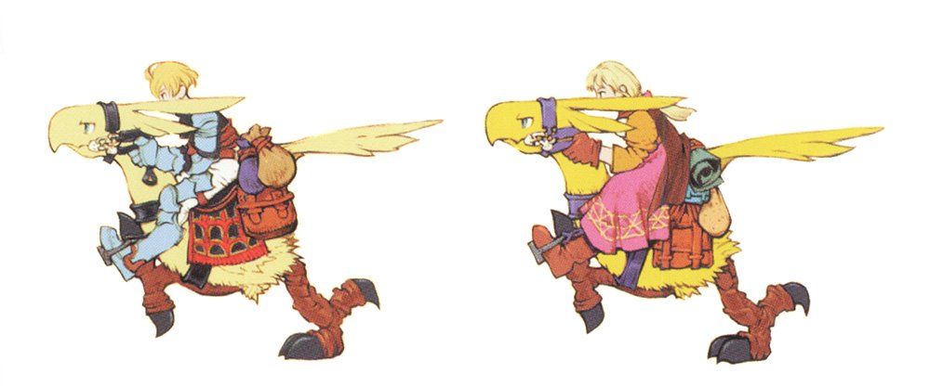Araguay Woods is located east of the Merchant City of Dorter. A sprawling forest covering the southern Lesalian region and inhabited by a variety of rare fauna. Its wood is famous in all Ivallice, and much of it adorns the richest castles in the kingdom.

Grogh Heights, also known as Grog Hill, is located between the Royal City of Lesalia and the Walled City of Yardrow. The heights compose the largest farm belt in the Lesalia region, and most of the crops harvested here are destined for the capital city. It is one of the oldest and most developed farmland regions of the entire kingdom.

Zeirchele Falls, also known as Zirekile Falls is a great waterfall located west of Fort Besselat. Few can help but be enchanted by the sight of Zeirchele Falls cascading down the stair like Algost Mountains. The waters of the falls go eastward to Limberry, to feed the riches of Dorvaudar.

Dugeura Pass, also known as Dogoula Pass, is located on the road between Riovanes Castle and Zeltennia Castle. Nearly 2,000 dohms in height, Mount Landria was once used by monks as a holy place of fasting and atonement. This passage is the safest route between the Grogh region and Bervenia, and even a small force could defend it from an attack, should the need arise.

## Campaign Ideas

### Mythological Heroes

Set in the Age of Myths, the players will explore the tales of the legendary heroes of Baron, Paramecia, Kushuka and Melmond. This age is akin to more traditional Final Fantasy histories – you got guns, magic and magitek, airships, flying continents, non-humans, and a general high-fantasy theme.

Adventure hooks include the wars between the kingdoms; the discovery of the Ronan ruins and artifacts; the Kashuka revolution; and the fight of the first Zodiac Braves against Lucavi and his demons.

### Ydoran Intrigue

The Holy Ydoran empire was a very busy place. Nobles and courtly intrigue abound, and while it still had the high levels of technology and magic of the previous era, the strict social order and iron fist enforced by the Ydoran rulers on their quick conquest makes this a prime candidate for espionage and social drama.

Along with that, the five decades before the Cataclism also saw the rise of St Ajora, who himself was also a Ydoran spy. Lots of religious conflict with the Pharism vs Ajora debate, along with the second Lucavi plot makes this a prime moment for adventures.

### Warring Kingdoms

Set in between the first and fifth centuries after the Cataclism, this campaign hook explores the conflicts between the six kingdoms of Kaladis and the rise to prominence of Mullonde and the Glabados Church.

In this moment of time, Lesalia, Fovoham, Zeltennia, Gallionne, Lionel and Limberry were independent kingdoms, forging aliances and warring constantly between themselves. Unlike the earlier eras, there are no more non-humans and high magic, with the technology level regressing to something like the early periods of the middle ages.

### Wars of Ivalice

This campaign idea is set in the sixty years between the two last major wars Ivalice has undergone: the Fifty Year’s war and the War of the Lions.

This period can be visited either to recreate the events of the videogame by another point of view, or to explore untold tales of unsung heroes from either side of the conflict.

How was life inside Romanda and what are the aftermatch of its defeat? What voices inside the Church begged for reason before they started to plot the Lion War? How the common folk reacted after the fall of the Corpse Brigade? These questions can warrant interesting stories to be told.

### The Schism

This is the default setting for this worldbook, set in 1250 A.C. The schism between the Ajoran and Glabados faiths sparks the underlying tensions of the kingdom, leading to the formation of the two religious leagues. Which side will the players take in the conflict? How will the other nations respond to Ivalice’s weaknesses? What are the secret motives of the major political players?

## 

## Game Option: Battle Map

Groups willing to experience an even more detailed combat system may use this optional mode for some or even all of its combat encounters. Use this optional system to simulate the strategy elements of the original Final Fantasy Tactics game. Be wary, however, that this implies a genre change and will place even more focus on the combat aspect of the game.

### The Move Stat

Add the MOVE stat for each character. It means the total number of squares the character may move with the **!Move** action. All characters start with a MOVE stat of 4, increasing by 1 for each 6 levels of the AIR stat. Abilities and Statuses may affect the MOVE stat.

**Weaken (Speed)**: Move reduced by 1.

**Strenghten (Speed)**: Move increased by 1.

**Toad**: Move reduced to 1.

**Berserk**: The character will move as close as possible to the nearest target within their line of sight before attacking, if able.

**Confuse**: Roll for confuse as normal; randomly pick a target that is within reach in accordance with the confuse roll. If this is not possible, roll a d4 for the cardinal directions, and then move as far as possible in that direction.

**Float**: The character is less hampered by harsh terrain.

**Flying**: Ignore all terrain while moving.

**Immobilize**: Move reduced to zero.

**Stone**: The character, as implied by the text, cannot move or act.

**Sleep**: The character, as implied by the text, cannot move or act.

**Stop**: The character, as implied by the text, cannot move or act.

### The !Move action

All characters gain the **!Move** action. You may use an action to move a number of squares equal to your Move stat. Once per round, when doing any action (but not during a reaction) you may also use the **!Move** action as a free action. If you do so, you can move either before or after doing the action. When moving, you walk in orthogonal directions counting one square at a time, so to move in a diagonal path you must spend two squares of movement for each diagonal square you walk (one forward then one to the left/right).

If the target of an ability moves during the windup of a Slow action, the ability remains targeted on them, as long as they remain within range. If a target moves outside the range of a Slow action, the character acting may retarget his action to another valid target in range. A character charging a Slow action can do a **!Move** action (either as a free action or by using an interrupt or delayed action), and move at the start of the phase before the Slow action is executed.

A character or monster may freely move through any allied space as long as they do not stop in the same space as their ally. They cannot move through a hex occupied by a foe. Whenever you do a successful **!Escape** action, you may also move a number of squares equal to your Move stat.

### Zone of Control

Characters wielding Melee weapons, or that can do Melee attacks for any reason (For example, an Archer who have the Point-Blank Specialty wielding a ranged weapon) project Zone of Control. Your Zone of Control is equal to all squares you can hit with a melee attack. Any enemy who tries to leave your Zone of Control must be successful with an **!Escape** action to do so.

Moving into a Zone of Control or any movement that does not leaves a character's Zone of Control is unimpeded. Forced movement (for example, if someone pushes or pulls a character) also ignores Zone of Control. Unarmed attacks does not project Zone of Control, as does any character with a status effect that prevents him from doing actions (**Sleep, Stop, Stone** and **Disable**). Reduce by 25 the difficulty of using **!Escape** against a target with the Blind status effect.

### https://vignette.wikia.nocookie.net/finalfantasy/images/a/ae/Agrias_Artwork.jpg/revision/latest/top-crop/width/240/height/240?cb=20090505223704Weapon Ranges

Some weapons are able to attack from further away than others. The Range is the number of spaces away from the character that they may attack. All weapons will also follow a Line of Sight, so should an obstacle or another target be in-between the Character and their Chosen target, the attack will instead hit the first obstacle or target in the Line of Sight.

**Light Swords/Knives, Heavy Weapons & Shield, Heavy Weapons, Claws/Gloves, Staves, Twin Weapons**: Any square adjacent or directly diagonal to the attacker.

**Polearms**: Any square up to 2 squares from the attacker.

**Throwing Weapons, Wands, Instruments**: Any square up to four squares from the attacker.

**Bows, Rifles/Crossbows**: Any square up to five squares from the attacker.

### Abilities, Spells and other special ranges

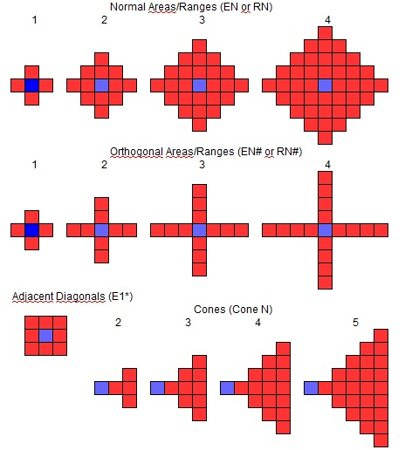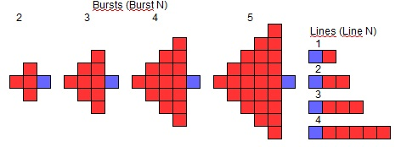All other ranges are written using the following notation: "R: Number; E: Number". R means range and “Number” is the number of squares away from the user where the user can select the target. A R rating of zero means the origin square of the effect is the user. E means effect and “Number” is the width of the effect, in squares. An E rating of zero means the effect targets only one square. For other range or effect ratings, see the diagrams below:

The blue square means the origin (either the character for the origin of the Range or the origin square for the origin of the Effect), while the red squares means either the squares that may be selected as the origin square (Range) or the squares affected by it (Effect). For Cones and Bursts, the origin square is not under the effects of the spell/ability, unless the ability or spell says otherwise.

### Types of Terrain

The terrain is categorized in various types. *Normal Terrain* is the usual terrain fights will take on. It is relatively plain, easy to traverse, and presents no danger to anyone. A normal road is a prime example of *Normal Terrain*.

*Difficult Terrain* is a terrain, which, while don’t pose any danger, is hard to traverse. To enter a square of *Difficult Terrain*, the character must spend an extra Move point. Characters under the **Float** or **Flight** status effects treat this terrain as if it was *Normal Terrain.* Shallow water, deep snow, ice, shrubs, debris and others may qualify as *Difficult Terrain.*

*Hazardous Terrain* is a terrain, which, while is easy to traverse, poses some danger to the characters. When the character enters a square of *Hazardous Terrain*, it takes damage equal to 10% of its maximum HP, ignoring Armor and Magic Armor. This damage may be either physical or magical, and be of any element, according to the terrain. Characters under the **Float** or **Flight** status effects treat this terrain as if it was *Normal Terrain.* Spikes, thorn shrubs, some traps and others may qualify as *Hazardous Terrain.*

*Deadly Terrain* is a terrain, which is not only hard to traverse but also poses a big danger to the characters. When the character enters a square of *Deadly Terrain*, it takes damage equal to 10% of its maximum HP, ignoring Armor and Magic Armor, and must spend an extra Move point. The character also suffers the same damage for each round he starts in this kind of terrain. Some terrains, at GM’s discretion, may inflict this damage each phase instead of each round. This damage may be either physical or magical, and be of any element, according to the terrain. Characters under the **Float** status effects treat this terrain as if it was *Hazardous Terrain,* and characters under the **Flight** status effect treat this terrain as if it was *Normal Terrain.* Lava, poisonous swamps, some traps and others may qualify as *Deadly Terrain.*

*Impassable Terrain* is a terrain, which you cannot traverse normally. Characters may not enter squares of *Impassable Terrain.* Characters under the **Flight** status effect treat this terrain as if it was *Normal Terrain.* Depending on the nature of the *Impassable Terrain*, you may be able to jump, climb or swim to reach the other side of it. Cliffs, rocks, deep water, tree trunks, walls and others may qualify as *Impassable Terrain*.

### Line of Sight and Line of Effect

When facing an obstacle, it might be important to check if you have line of sight and line of effect to your target. When in doubt, trace a straight line between any point of your square and any point in the target’s square. A small string can be very useful to do this. If there is at least one line that does not go through two opposite sides of an *Impassable Terrain* square, you have Line of Sight (LoS). You can see any characters you have Line of Sight to. Actions and Spells with E greater than zero hit any square from which the origin square has Line of Sight.

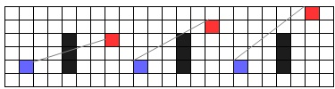To target a character with Attacks and Abilities, you must have Line of Effect. If there is at least one line that does not go through any two sides of an *Impassable Terrain* square, you have Line of Effect (LoE) to your target. In the examples below, the black squares are the Impassable Terrain.

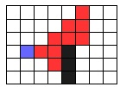 No LoS LoS but no LoE LoS and LoE

Cone 4 against an obstacle

### Giant Characters

Some characters may be greater than one square, occupying all of them at one time. For example, a monster may occupy a 2x2 square, a 3x3 square, a 2x1 rectangle or any other shape. When moving, giant characters treat all *Difficult* or *Hazardous Terrain* as *Normal Terrain*, unless all squares they occupy are *Difficult* or *Hazardous*. *Deadly Terrain* is treated as *Hazardous* *Terrain* for Giant Characters, unless all squares they occupy are *Deadly.* *Impassable Terrain* is treated as *Difficult Terrain* unless it covers at least one side of the giant character (For example, a 2-square wide wall will block the movement from a 2x2 giant, but not a 3x3 one).

When determining Line of Sight and Line of Effect to or from giant characters, you may choose any of the character’s squares as the origin or target of the line. Giant characters are only away from another character’s LoS if all of its squares are outside the LoS. All abilities and spells that can hit at least one square of the giant character hit it. Lastly, when determining the range of the giant character’s actions, you may use any of its squares as the origin square.

### Job, Actions and Spells in Map Combat

Several jobs have to be adjusted to work with the map combat rules. You can find the list of adjustments and new specialties for each Job, Action and Spell below. All weapon attacks not listed below use your weapon’s range. All reactions not listed below can be used whenever you meet its trigger. When a Spell or Action lists two different damages, one for single target and other for group target, use the single-target damage when it has only one character in its area of effect, and the group-target damage when it has more than one character in its area of effect.

**Main Jobs**

Adept

**!Snake Fang, !Hallowed Bolt** and **!Black Sky**: R:4 E:0

**!Shadeblade:** R:0 E:2. You are immune to the effects.

**!Stasis Strike**: R:3 E:0

**!Demi Shock**: R:4 E:0

**!Shellburst Stab**: R:6 E:0

**!Soul Eater** and **!Divine Ruination:** R:4 E:2. You are immune to the effects.

Archer

**!Barrage:** Use the weapon’s range. Attacks random enemies inside weapon range.

Artist

**!Dance:** R1* E:0. Two dances are exceptions: *Fatal Flamenco*targets four random enemies inside R: Move, and *Forbidden Dance* targets all enemies inside R: 0 E: Half Move.

**!Song:** R:4 E:0. Five songs are exceptions: *Requiem:* R:0 E:2. *Seraph Song*: R:4 E: 2 (target only allies). *Hero’s Ryme*: R: 0 E: 0. *Earth Blues* and *Nameless Song***:** R:4 E:1

**!Mimic:** All mimics use the same range and effect as the original action, except for *Take Over*, which is R: 4 E: 0

**!Throw:** R: 4 E: 0

**!Legend:** R: 6 E: 0. The target ally must be inside this range for you to react.

**!Hater**: R: 4 E:0

**!Do Over:** R: 6 E: 0. The target ally must be inside this range for you to react.

*Dedicated Fans:* You must be adjacent to the ally who reacts.Before you react, you may use the **!Move** action, either by spending the round’s free **!Move** action or by using an regular action to do so.

Black Magic

**Fire, Blizzard, Thunder, Blind, Petrify, Toad, Stone, Sleep, Zombie, Condemn, Death,Poison, Water, Dark, Rasp, Osmose, Drain, Syphon, Pain** and **Curse:** R: 4 E: 0

**Fira, Firaga, Blizzara, Blizzaga, Thundara, Thundaga, Waterga** and **Scourge**: R: 4 E: 1

**Magnitude** and **Quake:** R: 0 E: 3

**Bio, Venom, Meltdown, Freeze, Overcharge** and **Break:** R: 5 E: 0

**Storm and Scathe:** R: 4 E: 2

**Ultima** and **Doomsday:** R: 5 E: 2. You are immune to the effects.

**Flare**: R: 7 E: 0

Druid

**!Tame:** R: 1* E: 0

**!Air Wave:** R: 6: E: 0

**!Intimidate**: R: 4 E: 0

**!Earth Slash:** R: 0 E: Line 7

**!Weak Point**: R: 3: E: 0

**!Quagmire**: R: 4 E: 2. Choose one target inside the area of effect. You may use a powerup to affect all targets inside the area, according to the action description.

**!Parley**: R: 4 E: 0

Blue Magic

**Goblin Punch** and **Red Feast:** R: 1* E: 0  
**Choco Ball, Death Force, Flash, Transfusion, Acid, Degenerator, Dragon Force, Death Claw** and **Rippler**: R: 4 E: 0

**Self-Destruct, Hastebreak, 1000 Needles, Flame Thrower, Magic Hammer** and **Wall Change:** R: 5 E: 0  
**Nightsong, Poison Gas, Matra Magic, Seed Cannon, Stare** and **Frog Song**: R: 4 E: 1

**Aqua Rake** and **Electrocute**: R: 1 E: Burst 4. The origin square is also hit by the spell.

**Earth Shake, Grand Train** and **Supernova**: R: 6 E: 2   
**Force Field, White Wind** and **Mighty Guard**: R: 0 E: 2

**Level 3 Confuse, Roulette, Level 2 Old, Level 4 Flare** and **Level 5 Death**: R: 0 E: 8

**Bad Breath, Magic Breath** and **Stone Breath**: R: 0 E: Cone 5

**Shadow Flare**: R: 6 E: 0

Geomancy

**Gusty Wind, Gust, Icicle, Waterfall, Bottomless Pit, Back Alley, Phantom, Flame Blast, Antlion** and **Cosmic Flare**: R: 5 E: 0

**Sunbath, Wild Bear, Crowd Cheer, Earth Shield, Shining Air, Cosmic Embrace** and **Great Convergence**: R: 1 E: 2. Choose one target inside the area of effect. You may use a powerup to affect all targets inside the area, according to the Geomancy description.

**Pitfall, Plasma, Corrupt Water** and **Sandstorm**: R: 6 E: 2

**Leaf Swirl**: R: 4 E: 1

**Branch Spears**: R: 6 E: 3. Targets random enemies inside the area.

**Landslide, Sonic Boom, Avalanche, El Niño, Poison Mists, Cave In, Magma** and **Desert Storm**: R: 5 E: 1

**Ice Armor:** R: 3 E: 0

**Ghost:** R: 0 E: 1*. Targets only enemies.

Calls

**Asura, Fenrir, Ifrit, Lakshmi,Ramuh, Shiva** and **Valefor** (Basic Call) **:** R: 4 E: 1

**Chocobo:** R: 4 E: 0. Increase to E: 1 when using the Fat Chocobo.

**Valefor (Greater Call):** R: 0 E: 4. Choose up to three allies inside the area. After gaining the **Flight** status, you and all targets may move a numberof squares up to your Move stat. All movement done before your attacks with this action ignores Zone of Control, unless the enemy is also under the **Flight** status effect.

**Atomos, Carbuncle, Catoblepas** (Greater Call)**, Golem, Kirin** (Greater Call)**, Madeen, Titan** and **Unicorn** (Greater Call) and **Sraphim:** R: 5 E: 1

**Catoblepas** (Basic Call), **Kirin** (Basic Call) and **Unicorn** (Basic Call): R: 5 E: 0

**Silph:** R: 0 E: 3. Deals damage to one enemy and heals all allies inside the area.

**Alexander, Bahamut** (Greater Call)**, Diabolos, Kujata, Leviathan, Odin** (Greater Call) and **Zodiac:** R: 5: E: 2. Targets only enemies.

**Bahamut** (Basic Call), **Odin** (Basic Call) and **Phoenix** (Basic Call): R: 6 E:0

**Cerberus** (Basic Call): R: 0 E: 0

**Cerberus** (Greater Call): R: 4 E: 2. Choose up to four targets inside the area.

**Phoenix** (Greater Call): R: 6 E: 1. Deals damage inside the area of effect. Raises one ally inside the range, but not necessarily inside the area of effect.

**Bomb:** R: 5 E: 0. The additional **!Summon** damage is dealt to E: 1* centered on the Call target.

**Mind Flayer:** R: 5 E: 0.

**Mist Dragon, Maduin:** R: 5 E: 1.

**Crusader** (Basic Call)**:** R: 4 E: 2

**Crusader** (Greater Call)**:** R: 4 E: 3

**Ragnarok:** R: 7 E: 0

Monk

**!Doton, !Fuuton, !Katon** and **!Suiton**: R: 3 E: 0. Change to R: 0 E: Cone 3 with the Elan Specialty.

**!Punch Rush:** R: 1* E: 0

!**Kick:** R: 2 E: 1*

**!Aura Bolt** and **!Dark Bolt:** R: 5 E: 0

**!Atemi:** R:1* E:0

**!Kuuton:** R:4 E:2

**!Phantom Rush:** R:1* E:0

Rogue

**!Steal:** R: 1* E: 0

**!Detect, !Peep** and **!Lucky Odds**: R: 4 E: 0

**!Karma:** R: 6 E: 0. The target enemy must be inside this range for you to react.

**!Dice:** R: 3 E: 0

**!Dismantle:** R:1* E:0

**!Moogle Reels:** R:4 E:1. Targets only enemies.

**!Lucky Seven:** R: 6 E: 0. The target enemy must be inside this range for you to react.

**!Gil Toss:** R: 0 E: 3. Targets all enemies in the area.

**!Chocobo Reels**: R:4 E:2. You may choose between targeting only enemies or only allies.

**!Steal Heart**: R: 4 E:0

**!Distract**: R: 1* E: 0

Time Mage

**!Phase:** After being successful, choose a square adjacent to the attack’s area of effect. You teleport to that square.   
**!Delay:** R: 6 E: 0. The character using the spell must be inside this range for you to react.

Time Magic

**Burn Ray, Remove, Gravity, Demi, Quarter, Black Hole, Yawn, Slow, Stop, Mental Down, Armor Down, Power Down, Magic Down, Mental Up, Armor Up, Power Up, Magic Up, Speed Up, Tractor, Flight, Haste, Regen, Immobilize, Disable** and **Reset:** R: 4 E: 0

**Escape:** R: 0 E: 0. You teleport to an adjacent square. For each 5 levels in Fire, you can teleport one extra square. You still have to be successful to leave Zone of Control.

**Teleport:** R: 0 E: 3. You and your allies teleport to an adjacent square. For each 2 levels in Fire, you can teleport one extra square. You still have to be successful to leave Zone of Control.

**Quicken:** R:0 E: 0

**Ray Bomb, Quasar, Shockwave Pulsar,** **X-Zone, Slowga, Hastega, Float** and **Return:** R: 4 E: 1

**Meteorite, Comet** and **Meteo:** R: 4 E: 2. Targets random enemies inside the area.

**Old:** R:6 E: 0

**Time Stop:** R:6 E: 1

**Meteor:** R:5 E: 3. Targets random enemies inside the area.

Warrior

**!Arc**: R:6 E:0

**!Jump:** After gaining the **Flight** status, you may move a numberof squares up to half your Move stat. All movement done before you attack with this action ignores Zone of Control, unless the enemy is also under the **Flight** status effect.

**!Quadra Slam:** R:0 E:4. Targets four random enemies inside the effect area.

**!Life Break:** R:1* E:0

**!Armor Break, !Magic Break, !Mental Break** and **!Power Break, :** R:1* E:0. Change it to Burst 2 with the *Destruction Mastery* Specialty.

**!Slash All:** R:0 E: Burst 3. Targets three enemies inside the burst area. Increase to all enemies targets inside a Burst 4 with the *Wide Cleave* specialty.

**!Blade Beam:** R: 5# E: Cone 3. The primary target is the cone origin square. Targets two secondary targets inside the cone area. Increase to all secondary targets inside the cone area with the *Wide Cleave* specialty.

**!Dragon Breath:** R:1* E:0

**!Shock:** R: 0 E:3. You are immune to the effects.

**!Cleave:** R: 4# E:2. You are immune to the effects.

White Magic

**Cure, Poisona, Basuna, Esuna, Aero, Banish, Resist, Immune, Absorb, Raise, Arise, Reraise, Protect, Wall, Shell, Reflect, Blink, Vanish, Silence, Berserk, Confuse, Charm, Scan, Weaken, Shield:** R: 4 E:0

**Cura, Curaga, Aera, Aeraga, Banishra, Banishga, Protectga, Shellga, Ruse, Vaccine** and **Rebirth:** R: 4 E: 1

**Fade** and **Renew:** R: 5 E: 0

**Whirlwind:** R: 4 E: 2

**Holy:** R: 6 E: 0

**Secondary Jobs**

Alchemist

**!Treatment:** R: 4 E: 0

*Distribute:* R:0 E: 2. The area is centered on the character healed. Targets only allies.

**!Mix:** Healing items that targets a Group with **!Mix** heal on an E: 1 area.

New *Quick Hands* Specialty: *Throw Item:* Requires Air level 4. When you use healing items, they reach R: 4 instead of R: 1*.

New *Quick Hands* Specialty: *Battlefront Medic:* Requires Air and Earth level 3. Once per round, when you use the **!Draw** action, you may use the **!Move** action as a free action.

Berserker

*Counter Attack:* Before you Counter Attack, you may use the **!Move** action, either by spending the round’s free **!Move** action or by using an regular action to do so. **!Hamedo:** Has the same range as your **!Attack** action.

**!Provoke:** R: 4 E: 0

**!Howl:** R: 4 E: 0

**Dispel:** R: 5 E: 0

New *Counter Attack* Specialty: *Nimble Retort:* Requires Water level 3. When you declare your Counter Attack*,* ignore enemy Zone of Control this phase.

New *Provoke* Specialty: *Counter Disengage:* Requires Water level 9. You can *Counter Attack* when enemies declare the **!Escape** action against you.

Defender

**!Cover***:* To use **!Cover**, you must be adjacent to either the attacker or the ally who was hit.

*Sentinel:* Before you react, you may use the **!Move** action, either by spending the round’s free **!Move** action or by using an regular action to do so.

*Healing Wind:* Your **Healing** group Spells are all R: 4 E: 1.

*Noble Sacrifice:* May be used in any ally under your line of sight.

**Astra:** R: 4 E: 0

**Astra:** R: 4 E: 1

**Perseus’ Mirror:** The mirrored attack retain its original R and E values, using the Defender as the origin point of the range.

**Great Gospel:** R: 0 E: 0

New *Cover* Specialty: *Trip:* Requires Earth level 4. Whenever an enemy try to use the **!Escape** action against you, use the greater between Air or Earth as the Defensive Stat.

New *Share the Pain* Specialty: *Vanguard:* Requires Air and Water level 7. Allied characters ignore enemy Zone of Control while moving inside your Zone of Control.

Dervish

New *Ambidexterity* Specialty: *Bladedancer:* Requires Air and Water level 4. Whenever you use the **!Attack** action, you may move one square before attacking. This movement ignores ZoC.

New *Critical Speed* Specialty: *Guardbreaker:* Requires Earth and Air level 7. Enemies hit by your weapon do not project Zone of Control this phase.

Fencer

**!Swarmstrike:** R: 2 E: 0

*Coverage:* You must be adjacent to either the attacker or the ally to protect an ally.

New *Block Projectiles* Specialty: *Elusive Movement:* Requires Air level 5. When you declare the **!Move** action, choose one enemy. You ignore that enemy’s Zone of Control.

New *Preemptive Strike* Specialty: *Indirect Shot:* Requires Earth level 12. Increase the range of your *Ranged* physicalattacks by one square.

Phalanx

**!Shield Wall:** R: 0 E: 1*. All allies affected must be inside the effect area.

**!Meatbone Slash:** R: 1 E: 0

New *Tireless* Specialty: *Hold the Front:* Requires Air level 11. Your Zone of Control is *Difficult Terrain* for enemies.

New *Unshakable* Specialty: *Towering Shield*: Requires Earth and Air level 11. Whenever you are hit by a physical attack, treat your square as *Impassable Terrain* to determine LoS and LoE.

Rune Knight

*Runic Area:* You must be adjacent to either the attacker or the target of the spell to **!Runic** the spell on an ally.

*Offensive Runes:* Your **!Runic** becomes R: 6 E: 0. The target of the spell must be inside that range.

**!Magic Ruin:** R: 4 E: 0

**!Dispel Strike:** As your weapon’s range.

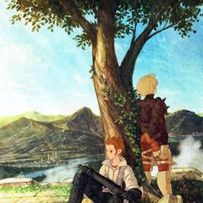*Anti-Magic Zone:* Your **!Dispel Strike** becomes R: 0 E: 4

**!Triple Magic:** As the original Spell.

**!Spell Ruin:** R: 1 E: 0

New *Spell Protection* Specialty: Arcane Weapons: Requires Fire and Water level 5. Your Instruments and Wands weapons project Zone of Control as if they were Melee.

New *Dispel Magic* Specialty: *Spellshield:* Requires Fire and Water level 11. Whenever you are hit by a Spell or magical attack, treat your square as *Impassable Terrain* to determine LoS and LoE.

Wizard

**!Shieldbreak:** R: 0 E: 2

New *Counter Magic* Specialty: *Distant Spell:* Requires Fire level 12. Your Spells with R: 2 or greater increase their range by one square.

New *Silent Spell* Specialty*: Graceful Casting:* Requires Earth and Water level 14. Whenever you cast a Spell, you may choose up to two characters in the Spell's area of effect. Your spell does not target the chosen characters.

## New Main Job: Freelancer

*Versatility:* Core Ability acquired at level 1. Your HP bonus is 3x your level, and increases by 1x your level at levels 15, 30 and 60. Your MP bonus is 1x your level, and increases by 1x your level at level 30.

*Job Change:* Core Ability acquired at level 1. Choose a Main Job. You undergo a Job Change to the chosen Job. You can equip the weapons and armor as if you had the first Ability of this Job. Each time you spend Job Points, you must undergo a Job Change to a Job which Abilities you just acquired. Whenever you make a Job Change, treat as you had the new Job to determine which weapons and armor you may equip, instead of the previous. You may only keep the option to equip a piece of gear if you have an Ability that permanently grants access to a weapon or armor type. Your abilities other than *JP UP* may not change your HP and MP bonuses. Lastly, you may not acquire any Main Job’s Specialties unless by spending Job Points.

*JP UP:* Core Ability acquired at level 8. Gain 3 Job Points (JP). You may spend them accordingly to the table below. You may spend less than your total Job points, but cannot spend them again until you gain more Job Points. To gain any Core Ability or Specialty this way, you must respect all the Ability's required levels.

| Ability Gained | JP Cost | Special |
| --- | --- | --- |
| Increase your HP multiplier by 1 | 1 | May be chosen once |
| Increase your HP multiplier by 1 | 2 | May be chosen twice |
| Increase your MP multiplier by 1 | 2 | May be chosen twice |
| *Awakened* Core Ability | 3 |  |
| *Natural Domain* Core Ability | 2 |  |
| *Arcane Devotion* Core Ability | 2 |  |
| First Ability which grants Spell Groups | 2 | Other than Arcane Devotion |
| Second or later Ability granting Spell Groups | 1 | Ignore Arcane Devotion on this count |
| Specialty from a Core Ability which you already have a Specialty | 2 |  |
| Any other Core Ability or Specialty | 1 |  |

*JP UP*: Core Ability acquired at level 16. Gain 1 Job Point. You may spend any Job Points you have stored immediately.

*JP UP:* Core Ability acquired at level 23. Gain 1 Job Point. You may spend any Job Points you have stored immediately.

*JP UP:* Core Ability acquired at level 30. Gain 1 Job Point. You may spend any Job Points you have stored immediately.

*JP UP:* Core Ability acquired at level 37. Gain 1 Job Point. You may spend any Job Points you have stored immediately.

*JP UP:* Core Ability acquired at level 44. Gain 1 Job Point. You may spend any Job Points you have stored immediately.

*JP UP:* Core Ability acquired at level 51. Gain 1 Job Point. You may spend any Job Points you have stored immediately.

*JP UP*: Core Ability acquired at level 58. Gain 1 Job Point. You may spend any Job Points you have stored immediately.

*JP UP:* Core Ability acquired at level 65. Gain 1 Job Point. You may spend any Job Points you have stored immediately.

## New Secondary Job: Squire

While many believe that a squire is just a knight in training, some Squires never leave this status. Forgoing formal training, they never progress beyond the basic training of another Job, relying on their innate talents and intuition to progress. Be a Squire if you want to control the battlefield using offensive actions instead of reacting. Abilities marked with * requires the Battle Map combat rules.  
  
*Basic Skill:* Core Ability earned at level 1. Choose another Secondary Job. You earn that job’s first level Core Ability. Regardless of the chosen Job, the Specialties for *Basic Skill* are:

*Throw Stone:* Requires Earth and Air level 2. You gain the *Ranged* Quick physical action **!Throw Stone.** You gather a rock and throw at your opponent, making an Air vs Air, dif 40 attack. If you hit, you deal Crush-elemental damage equal to the level-appropriate Throwing Weapon’s damage. With Battle Map, this action has R: 3 E:0.

*Equip Axe:* Requires character level 1*.* You may equip Heavy Weapons and Heavy Weapons & Shield.

*Artful Dodger:* Requires Earth and Air level 5. Reduce your **!Dodge** action’s difficulty to 40.

*Dash*:* Requires Earth level 3.You gain the *Melee* Quick physical action **!Dash**. You bodyslam at your target, attacking with your weapon. Do a weapon attack, inflicting normal damage, and pushing your target one square backwards. If you manage to achieve a critical hit, the target is also gains the **Immobilize** status until after his next action. With Battle Map, this action has R: 1* E: 0

*Move-Up*:* Requires Air level 3. Increase your Move by 1.

*Accumulate:* Core Ability earned at level 19. You gain the Slow(4) Physical action **!Focus**. Using it, you accumulate strength for your next blows. You gain the **Strengthen (Physical)** status until the end of the next round. Specialties:

*Mana Well:* Requires Water level 10. Your **!Focus** action can be used to give the **Strengthen (Magic)** status effect instead of **Strengthen(Physical)**.

*Counter Tackle:* Requires Air level 8. Whenever an enemy tries to use the **!Escape** action against you, increase his difficulty by 20.

*Magical Traps*:* Requires Fire and Earth level 11. You may create magical traps. When using a magical ability or Spell, you may target a square in range and any phase up to the end of the next round. At the start of the chosen phase, the Ability or Spell detonates, inflicting its effects, and using the chosen square as the origin point of the Area of Effect, if applicable. Whenever a character moves into the chosen square before the chosen phase, you may detonate the trap early.

*Overwhelm Defenses:* Core Ability earned at level 35. Once per phase, when you miss an attack, you may increase the difficulty by 20, to a maximum of 99, to re-roll it.

*Awareness:* Requires Fire level 16.You gain the *Ranged* magical action **!Awareness**. Do a Fire vs Air, dif 0, attack against all enemies. Your acute senses detect traces of enemy presence. All enemies hit lose the **Vanish** status effect. With Battle Map, this action has R:0 E:4.

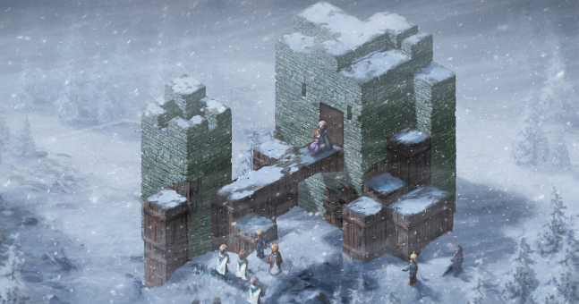*Faith and Bravery:* Requires Earth and Water level 13. Whenever you are under the effects a **Weaken** status effect, gain a **Strengthen** status effect. **Weaken (Armor)** gives you **Strengthen (Physical)**. **Weaken (Mental)** gives you **Strengthen (Magical)**. **Weaken (Physical)** gives you **Strengthen (Armor)**. **Weaken (Magical)** gives you **Strengthen (Mental)**.

*Mighty Dodge:* Requires Air and Earth level 13. You may use the **!Attack** action as a free action after you succeed with the **!Dodge** action.

*Tailwind:* Core Ability earned at level 50.You gain the *Ranged* Quick action **!Yell**. Use it on an ally. The target gains one extra initiative die with the value equal to the current phase. With Battle Map, this action has R:4 E:0.

*Ordered Retreat:* Requires Air and Water level 16.When you succeed with the **!Escape** action, treat as if all allies succeeded with a **!Escape** action this phase.

*Graduation:* Requires Earth, Air, Fire and Water level 12. Choose an action of any other Secondary Job. You gain that action. This ability cannot grant reactions.

## Bestiary

Most of the enemies in the game are regular human beings, but there are several monsters in Ivalice.

#### Floating Eye

10th level Beast Aberration **Minion**

Earth 12 Air 41 Fire 38 Water 24

HP 40 MP 20 ARM 02 MARM 10

Move 5 Initiative – 2 die

*Wing Buffet:* Quick physical action, Air vs Earth, dif 40, 24 damage (Crush), R1* E0

*Dread Gaze: Ranged* Slow (2) magical Action, Fire vs Fire, dif 40, inflicts **Weaken (Physical)** until end of next turn, R4 E0

[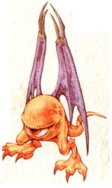](https://vignette.wikia.nocookie.net/finalfantasy/images/d/db/FFT-Ahriman.jpg/revision/latest?cb=20071213122944)**Vulnerable (Ice), Resist (Air), Vulnerable (Blind), Auto-Flight**

*Huge eyeballs with wings, these aberrations travel in flocks and uses a baleful stare to attack its enemies. The strongest forms of these enemies can even petrify their foes with just a glare.*

#### Goblin

27th level Humanoid **Common**

Earth 91 Air 87 Fire 46 Water 60

HP 250 MP 40 ARM 22 MARM 18

Move 5 Initiative – 3 die

*Tackle:* Quick physical action, Earth vs Air, dif 40, 45 damage (Cut), R1* E0

*Spin Punch:* Quickphysical action, Air vs Air, dif 40, 40 damage (Crush), attacks all enemies, R0 E1*

*Eye Gouge:* Quickphysical action, Air vs Earth, dif 70, 40 damage (Puncture), inflicts **Blind** until the end of next turn, R1* E0

**Vulnerable (Ice and Shadow)**

[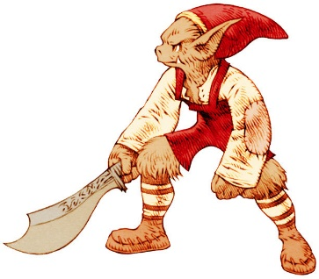](https://www.google.com.br/url?sa=i&rct=j&q=&esrc=s&source=images&cd=&cad=rja&uact=8&ved=0ahUKEwjG37yXwvjWAhVJgZAKHVO6B5sQjRwIBw&url=http://finalfantasy.wikia.com/wiki/Goblin_(Tactics)&psig=AOvVaw1fFciBp6YXwvyP_OgAyFRL&ust=1508359116127400) *Diminute humanoids with limited speech, these tribal foes have large ears and an upturned nose. Surprisingly strong for its small size.*

#### Revenant

39th level Humanoid Undead **Common**

Earth 92 Air 94 Fire 128 Water 94

HP 608 MP 502 ARM 46 MARM 69

Move 4 Initiative – 3 die

*Ectoplasm: Ranged* Quick magical action, Fire vs Earth, dif 40, 120 damage (Shadow), R3 E0

*Sleep Touch:* Slow (2) magical action, Fire vs Water, dif 60, inflicts **Sleep** until end of next turn, R1* E0

*Weaken*, White Spell, 82 MP, Fire vs Water, dif 70, inflicts **Vulnerability(chosen element)** until end of next turn, R4 E0

*Roulette,* Blue Spell, 80 MP, Fire vs Water, dif 40, reduce a random combatant to 0 HP, R0 E8

**Vulnerable (Light and Fire), Resist (Ice), Absorb (Shadow), Immune (Transform, Toxic, Mental), Auto-Float, Auto-Zombie**

*A restless incorporeal spirit. A mere touch may suck the life from its target, causing debilitating status effects. These are amongst the strongest of the ghosts found in the old ruins and wastelands of Ivalice.*

